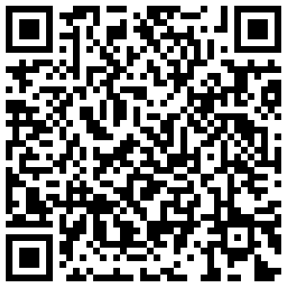

UNLOCK YOUR VOICE (and the QR Code)  
shorturl.at/djmN4  
**PASSWORD: Sing**  
INSTA: @j.c.geiger // TWITTER: @jcgeiger

UNLOCK YOUR VOICE (and the QR Code)  
shorturl.at/djmN4  
**PASSWORD: Sing**  
INSTA: @j.c.geiger // TWITTER: @jcgeiger

UNLOCK YOUR VOICE (and the QR Code)  
shorturl.at/djmN4  
**PASSWORD: Sing**  
INSTA: @j.c.geiger // TWITTER: @jcgeiger

UNLOCK YOUR VOICE (and the QR Code)  
shorturl.at/djmN4  
**PASSWORD: Sing**  
INSTA: @j.c.geiger // TWITTER: @jcgeiger