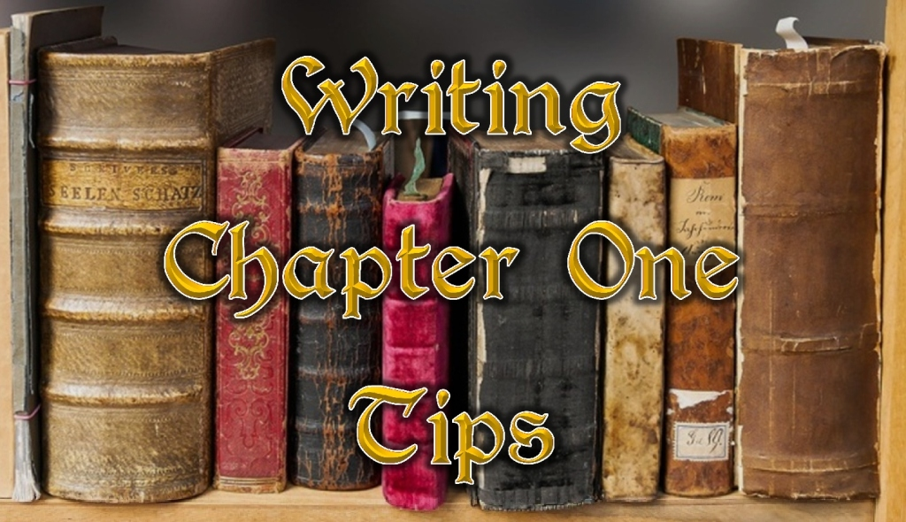

Greetings, Storytellers!
I’ve wanted to write about first chapters for a while, primarily because they’re so important. After all, they’re the gateway to Chapter 2, and getting a reader to Chapter 2 is a fantastic idea.
Before I get into the elements of a powerful first chapter, let's touch briefly on different ways to open a book.
There are actually a number of perfectly legitimate types of first chapters. Here are four common ones with brief descriptions:
The Prolog - A prolog is an episode that pertains to your story but is in some way outside your main narrative. It may look back at a time long ago, or give a glimpse of the future. It may arise from an alternate POV to the main story, or provide a glimpse of important information to set up the tale's start.
The Hero-Action Beginning - In a hero-action beginning, the hero is onstage, doing something active and interesting related to the story's core or theme. It need not involve explosions and car chases, but it certainly can. This is the most common way to open a story.
The In Medias Res Beginning (in the middle of things) - With in medias res, you start at a point deep in the story, show a bit of activity to intrigue the reader, and then you hit the rewind button and spend some, or all, of the rest of the book catching up to that moment.
The Frame Device - The final common way of beginning your first chapter is to use a frame device. In this, your story is bookended on the front and back (and usually a few instances in the middle) by a story that is outside the main story. The primary tale is framed by this other story.
With that out of the way, I went in search of tips that apply to Chapter Ones, regardless of the genre, tips that I could use as I conceive of, write, and edit my stories. As usual, there are exceptions to these tips, and the list is not exhaustive.
Context: Backstory, Setting, and Detail
- Avoid backstory. Include the bare minimum necessary and trickle the rest in as needed.
- Don’t overdo setting. Give a smattering of strong, vibrant details to establish a sense of place and time. Then fill in the rest later as the story unfolds.
- Connect the character to the setting so it isn’t just a backdrop. You might show how the character interacts with the setting.
- There’s no need to skimp on details that serve the story. If your story is about snipers, give sniper details. Make sure they’re sharp and interesting. Avoid being vague. Write tight!
Structure: Theme, Mood, and Plot
- Start the book as late in the story as you can. Does your story still work if you start with Chapter 2? If so, cut chapter 1.
- Write a great first line. A great first line grabs the reader’s interest.
- The theme is the argument that the story is making. The first chapter should hint at the theme.
- Establish your mood. Ask yourself how you want the reader to feel while reading the book.
- Think of every chapter as a short story with a mini-plot and conflict, especially Chapter One.
- Avoid telegraphing. Let the immediacy of the action carry the chapter to the end. Keep your POV tight.
Character
- Most writing experts will recommend introducing your protagonist in the first chapter. Some recommend introducing your antagonist as well, though that isn't always possible. Avoid opening with other characters talking about the main character.
- Make your reader care about your character. How is your character at risk?
- Have your character engaged - active versus passive.
- Not absolutely necessary, but dialog is a great way to reveal character and conflict, and manage pace.
Conflict
- Have some sort of conflict – physical, emotional, or mental. Conflict disrupts the status quo. Conflict is drama, and it's interesting.
- You don’t need to spell out the stakes for the entire book in chapter one, but hint at why the conflict matters.
- A note on action: Rip-roaring action might be fun, but it’s best if the reader cares about the character first. Without an investment in character and context, an action scene can feel shallow.
Hooks
- End your first chapter (most chapters) with a moment of mystery, an introduction of conflict, or a twist of the tale. It doesn’t have to be a huge one; it just needs to be intriguing enough to propel the reader forward.
- Mystery. While action needs context, one of mystery’s strengths is that it makes the reader wait for context. It’s okay not to explain everything. At the same time, mystery does not equal confusion – find the balance.
That does it for today. Now off with you to craft that amazing first chapter.

Happy Writing!

